CS4121 Assignment 5 Due: 11/11/19
- (20 points) Consider the network shown below, and assume that each node initially knows the costs to each of its neighbors. Consider the distance-vector algorithm and show the distance table entries at each node iteration by iteration until the algorithm converges at all nodes.

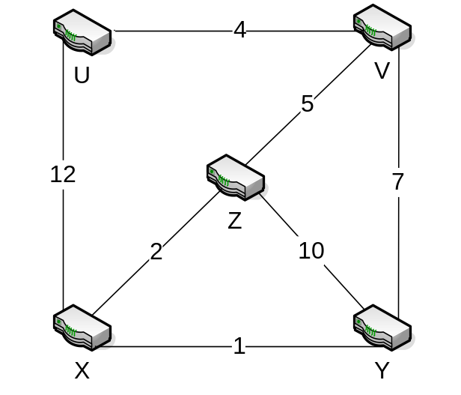

Iteration 0:

Basic known connections.

Du | U | V | X | Y | Z
U | 0 | 4 | 12 | ∞ | ∞
V
X

Dv | U | V | X | Y | Z
U
V | 4 | 0 | ∞ | 7 | 5
Y
Z

Dx | U | V | X | Y | Z
U
X | 12 | ∞ | 0 | 1 | 2
Y
Z

Dy | U | V | X | Y | Z
V
X
Y | ∞ | 7 | 1 | 0 | 10
Z

Dz | U | V | X | Y | Z
V
X
Y
Z | ∞ | 5 | 2 | 10 | 0

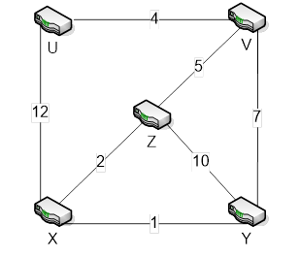
Iteration 1:

Nodes are passed distance vectors from neighbors and are updated.

Du | U | V | X | Y | Z
U | 0 | 4 | 12 | 11 | 9
V | 4 | 0 | ∞ | 7 | 5
X | 12 | ∞ | 0 | 1 | 2
Y and Z can now be reached through V.
Dv | U | V | X | Y | Z
U | 0 | 4 | 12 | ∞ | ∞
V | 4 | 0 | 7 | 7 | 5
Y | ∞ | 7 | 1 | 0 | 10
Z | ∞ | 5 | 2 | 10 | 0
X can now be reached through Z.
Dx | U | V | X | Y | Z
U | 0 | 4 | 12 | ∞ | ∞
X | 11 | 7 | 0 | 1 | 2
Y | ∞ | 7 | 1 | 0 | 10
Z | ∞ | 5 | 2 | 10 | 0
V can now be reached through Z. The path to U can be shortened using Z and V.
Dy | U | V | X | Y | Z
V | 4 | 0 | ∞ | 7 | 5
X | 12 | ∞ | 0 | 1 | 2
Y | 11 | 7 | 1 | 0 | 3
Z | ∞ | 5 | 2 | 10 | 0
U can now be reached through V. The path to Z can be shortened by using X.
Dz | U | V | X | Y | Z
V | 4 | 0 | ∞ | 7 | 5
X | 12 | ∞ | 0 | 1 | 2
Y | ∞ | 7 | 1 | 0 | 10
Z | 9 | 5 | 2 | 3 | 0
U can now be reached through V. The path to Y can be shortened by using X.
Iteration 2:

Nodes are passed distance vectors from neighbors and are updated.

Du | U | V | X | Y | Z
U | 0 | 4 | 11 | 11 | 9
V | 4 | 0 | 7 | 7 | 5
X | 11 | 7 | 0 | 1 | 2
The path to X can be reduced by using V and Z.
Dv | U | V | X | Y | Z
U | 0 | 4 | 12 | 11 | 9
V | 4 | 0 | 7 | 7 | 5
Y | 11 | 7 | 1 | 0 | 3
Z | 9 | 5 | 2 | 3 | 0
V distance vector doesn’t change.
Dx | U | V | X | Y | Z
U | 0 | 4 | 12 | 11 | 9
X | 11 | 7 | 0 | 1 | 2
Y | 11 | 7 | 1 | 0 | 3
Z | 9 | 5 | 2 | 3 | 0
X distance vector doesn’t change.
Dy | U | V | X | Y | Z
V | 4 | 0 | 7 | 7 | 5
X | 11 | 7 | 0 | 1 | 2
Y | 11 | 7 | 1 | 0 | 3
Z | 9 | 5 | 2 | 3 | 0
Y distance vector doesn’t change.
Dz | U | V | X | Y | Z
V | 4 | 0 | 7 | 7 | 5
X | 11 | 7 | 0 | 1 | 2
Y | 11 | 7 | 1 | 0 | 3
Z | 9 | 5 | 2 | 3 | 0
Z distance vector doesn’t change.
Iteration 3:

No nodes are updated so this is the final iteration.

Du | U | V | X | Y | Z
U | 0 | 4 | 11 | 11 | 9
V | 4 | 0 | 7 | 7 | 5
X | 11 | 7 | 0 | 1 | 2

Dv | U | V | X | Y | Z
U | 0 | 4 | 11 | 11 | 9
V | 4 | 0 | 7 | 7 | 5
Y | 11 | 7 | 1 | 0 | 3
Z | 9 | 5 | 2 | 3 | 0

Dx | U | V | X | Y | Z
U | 0 | 4 | 11 | 11 | 9
X | 11 | 7 | 0 | 1 | 2
Y | 11 | 7 | 1 | 0 | 3
Z | 9 | 5 | 2 | 3 | 0

Dy | U | V | X | Y | Z
V | 4 | 0 | 7 | 7 | 5
X | 11 | 7 | 0 | 1 | 2
Y | 11 | 7 | 1 | 0 | 3
Z | 9 | 5 | 2 | 3 | 0

Dz | U | V | X | Y | Z
V | 4 | 0 | 7 | 7 | 5
X | 11 | 7 | 0 | 1 | 2
Y | 11 | 7 | 1 | 0 | 3
Z | 9 | 5 | 2 | 3 | 0

